## Hutchins Center FIM projects waning fiscal impact on growth

The Fiscal Impact Measure (FIM) is a gauge of the contribution of federal, state, and local fiscal policy to near-term changes in the gross domestic product, the tally of all the goods and services produced in the economy. It includes both the direct effects of government purchases as well as the more indirect effects of government taxes and government transfers. When FIM is positive, the government is contributing to real GDP growth, and when it is negative, it is subtracting from it.

The Hutchins Center FIM uses quarterly data from the U.S. Commerce Department’s Bureau of Economic Analysis (BEA) to measure the contribution of fiscal policy to GDP growth. It includes both the direct effect of federal and state/local spending on GDP (which the Bureau of Economic Analysis calculates and can be found in Table 1.1.2 here) as well as an estimate of the indirect effects of fiscal policy on GDP growth through its effect on private consumption. The FIM forecast relies on the Congressional Budget Office’s 10-year projections of government spending, tax revenues, GDP growth, and inflation.

In CBO’s projections, inflation-adjusted federal government spending is projected to rise in the first half of 2019 but decline sharply in subsequent quarters, as new statutory caps on discretionary spending come into effect in fiscal year 2020. The FIM forecast assumes, however, that the existing discretionary spending caps will remain in place and that federal spending will grow at its longer-term rate after November 2019. This implies that federal spending will have a waning but positive effect on GDP in the coming quarters. If current law were to remain in place, federal spending would likely become a drag on GDP growth by the end of 2019.

In contrast, state and local spending is projected to increase moderately over the next two years, as broader growth boosts tax revenues and demand for the services those governments provide. The FIM projects that state and local spending will add about xx percentage points to annual GDP growth in each of the next two years.

The effects of taxes and transfers on GDP growth are projected to wane in the coming quarters. CBO projects that transfers under the main entitlement programs—Social Security, Medicare, and Medicaid—will rise by 5 percent in 2019 and at a similar rate in subsequent years, providing a steady infusion of spending into the economy. Federal taxes are likely to grow at a rate consistent with the economy, with the exception that corporate taxes are expected to grow slightly faster in the coming years.[1]

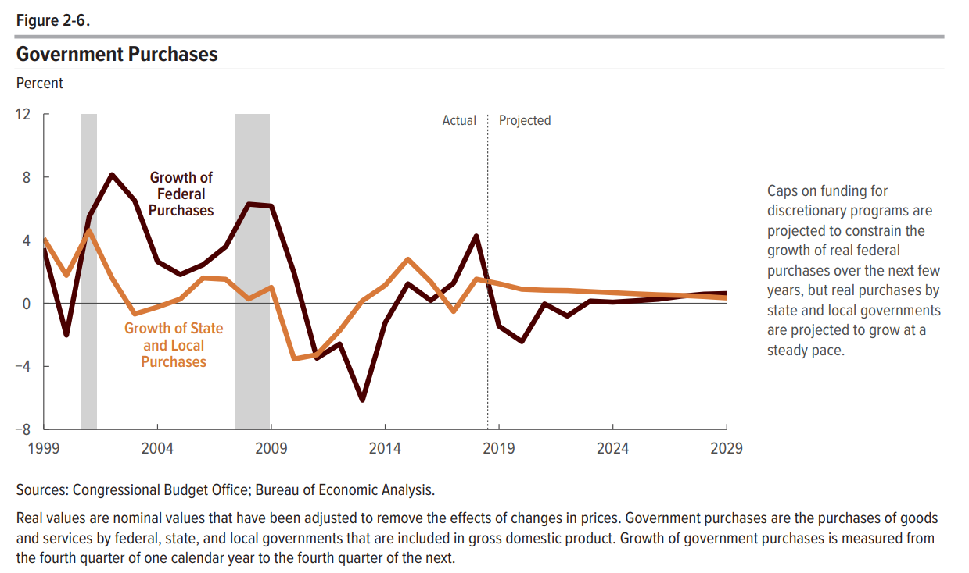

1. CBO offers two explanations. The first is “unexplained weakness” in recent receipts, that CBO expects to dissipate. The second is that some TCJA provisions phase out in 2022, like the full-expensing provisions, and imply a slightly steeper path for corporate tax income.